SPONSORSHIP AGREEMENT FORM
Name: _______________________________________________________________________
Name/Title as it should appear on website: __________________________________________
Company:________________________________________________________Anonymous:___
Address:______________________________________________________________________
City/State/Zip:__________________________________________________________________
Telephone:_____________________________________________________________________
E-mail:_________________________________________________________________________
SPONSORSHIP PARTICIPATION LEVEL (check one):
Champion Level Title Sponsor: ____ $5,000.00
Ironman Level Sponsor: ____ $3,000.00
Olympic Level Sponsor: ____ $1,000.00
Sprint Level Sponsor: ____ $750.00
Team K-KREW Sponsor: ____ $300.00
K17 SPORT Krew Member: ____ $100.00
Other: $____________
Other Opportunities for Sponsorship:
Championship Race Sponsor (Fill in amount and specific race you would like to sponsor):
$___________________________________________________________________________________
*Please contact me at K17SPORT@gmail.com for more information
Gear Donation (list items to be donated and estimated cost): __________________________________

*Make checks payable to: Kenrick Smith and put Attn: K17SPORT.com on check
For more information please call 484.560.1751, email K17SPORT@gmail.com or visit website
www.K17SPORT.com
Please mail the completed form with payment to: 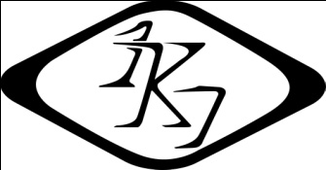
Kenrick Smith
3790 Bellview Road
Schnecksville, PA 18078

